[DATABASE TECHNOLOGY](https://www.kth.se/social/course/DD1368/)

DD1368 | 6.0 CREDITS

HOMEWORK -4-

*Doren Calliku*

*Group 8*

**Homework exercise:**

Study the Northshore Hospital case study file available on Canvas, using the following

Figure1:

1. Identify the functional dependencies represented by the attributes shown in the form in Figure 1. State any assumptions that you make about the data and the attributes shown in this form.
2. Describe and illustrate the process of normalizing the attributes shown in Figure 1 to produce a set of well-designed 3NF relations.
3. Identify the primary and foreign keys in your 3NF relations.
4. Examine the 3NF relations created to represent the attributes shown in the Hospital form shown in Figure 1.

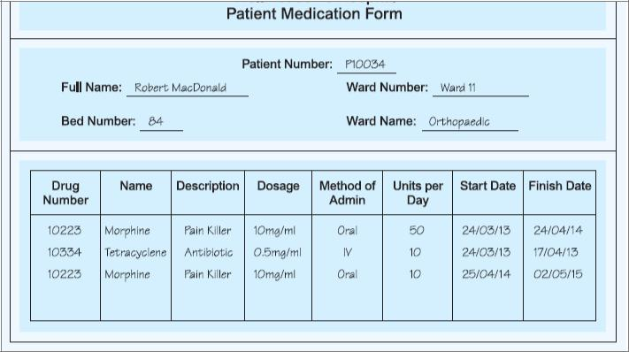

Figure 1. Hospital Patient Medication Form.

A) Identify the functional dependencies represented by the attributes shown in the form in Figure 1. State any assumptions that you make about the data and the attributes shown in this form.

Functional dependencies are the constraints that describe the relationship between attributes in a relation. It happens between two sets of attributes. So, if we have a set of attributes called A in a relation X, and each value of it is related(associated) with exactly one value of another set of attributes B, then we have a functional dependency from A to B. Another way to interpret the functional dependencies is that F(A)→B, so B is dependent on value of A, or two tuples(data) sharing the same value of A will have the same value of B. If a row is added where the student had a different value of semester that the functional dependency, F, would no longer exist. So functional dependencies are dependent on data.

In order for us to express functional dependencies we have to have tables(or relations) in which we define which attributes are connected to which attributes by a functional dependency. So, we got only the table for the drugs, as to include a table in which only one tuple is given, as the patient medication form, it is practically meaningless. We also assume to take some of the features of the normalization process, in order to not make meaningless associations between data and attributes.

Functional Dependencies are the following:

Drug Number → {Name, Description, Dosage}

{Drug Number, Start Date} → {Method of Admin, Units/day/ Finish Date}

OR in place of Start date can be any of the other attributes. The start date was chosen for logical implication that Start Date would define the other ones, as the medication might have been given on that day. The other possibilities are still mathematically possible.

Assuming that our assumption that we have to deal only with the table might be wrong (because we got a little number of results) we can discuss about “Expected Functional Dependencies” which are the ones that one would expect to happen, but because of lack of data we cannot say that they are dependencies.

Patient Number → {Full Name, Ward Number, Bed Number}

Ward Number → Ward Number

Note: The dates in the “Finish Date” are a little unbelievable.

b) Describe and illustrate the process of normalizing the attributes shown in Figure 1 to produce a set of well-designed 3NF relations.

Normalization process is used to avoid or eliminate the problems that can arrive with data in a database system, those being: insertion, deletion and updating.

First normal form of the relation is when all of its attributes are simple, so none of them is a relation. We can do this by creating superkeys from tables, by uniting two primary keys. Then fully functionally dependent keys are registered.

Second normal form happens when all the non-primary attributes of the relation are fully functional on the primary key. So, we check the attributes which have functional dependencies and try to divide them so that we do not get any non primary attribute.

Third Normal Form happens when a second normal form relation if all non-primary attributes (that is attributes that are not parts of the primary key or of any candidate key) have non-transitivity dependency on the primary key.

The process of normalizing the relation will assume that we take the whole medication form and also it will assume that some logical implication follow based on previous information in previous homeworks, and the North Case Study. So the decisions will not based only on the information in the form.

Point 1. The relation between the big relation and the relation included in it can be expressed by two tables, first one having as a primary key the patient number, and the second one the drug number and the start date (with candidate keys: drug number+ units per day, drug number + finish date).

Point 2. The information about the patient can be divided into two tables, first one including patient number as primary key and also the connection between ward number and ward name is brought alone. To mention is that we do not include the bed number as defined from the primary keys of these two primary keys because it would allow needless redundancy. Still in the future it might be allowed.

Point 3. We continue to divide the table of the medication as we started in point two.

Table 1.

| Ward Number | Ward Name |
| --- | --- |
| 11 | Orthopaedic |

Table 2.

| Patient Number | Name | Bed | **Ward Number** |
| --- | --- | --- | --- |
| P10034 | Robert McDonald | 84 | **11** |

Table 3.

| **Drug Number** | Units per day | Start Date | Finish Date |
| --- | --- | --- | --- |
| **10223** | 50 | 24/03/13 | 24/04/14 |
| **10334** | 10 | 24/03/13 | 17/04/13 |
| **10223** | 10 | 25/04/14 | 02/05/15 |

Table 4.

| Drug Number | Name | Description | Dosage | Method of Admin |
| --- | --- | --- | --- | --- |
| 10223 | Morphine | Pain Killer | 10mg/ml | Oral |
| 10334 | Tetracyclene | Antibiotic | 0.5mg/ml | IV |

Table 5.

|  |  |  |
| --- | --- | --- |
| **Patient Number** | **DrugNumber** | **Start Date** |
| **P10034** | **10223** | **24/03/13** |
| **P10034** | **10334** | **24/03/13** |
| **P10034** | **10223** | **25/04/14** |

C) Identify the primary and foreign keys in your 3NF relations.

D) Examine the 3NF relations created to represent the attributes shown in the Hospital form shown in Figure 1.

Identified Primary keys on yellow, foreign keys on **Bold**.

Examination and analysis is done on question b. Still, to mention is the last table which is to connect the other tables together. The visual connection is shown in the picture.

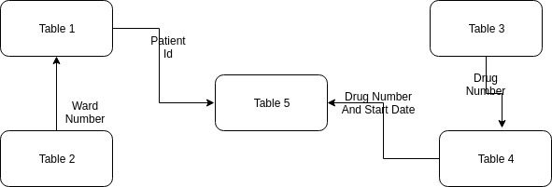

**Extra queries:**

The relation shown in Figure 2 describes hospitals (hospitalName) that require certain items (itemDescription), Which are supplied by suppliers (supplierNo) to the hospitals (hospitalName).

Furthermore, whenever a hospital (h) requires a certain item (i), and a supplier (s) supplies that item (i), and the supplier (s) already supplies at least one item to that hospital (h), then the supplier (s) will also supply the required item (i) to the hospital

(h). In this example, assume that a description of an item (itemDescription) uniquely identifies each type of item.

1. Describe why the relation shown in Figure 2 is not in 4NF.
2. Describe and illustrate the process of normalizing the relation shown in Figure 2 to 4NF.

A)

A table is in fourth normal form if and only if for every multivalued non-trivial dependencies X→>Y, X is a superkey.

A non-trivial multivalued dependency happens if we choose any x actually occurring in the table, and combine a list of where it is found, the we will see that y is connected to x no matter how z(another attribute) behaves. Practically, what multivalued dependency tries to constrain is the possibility of a data corruption where a value of x is not spread to y independently to z.